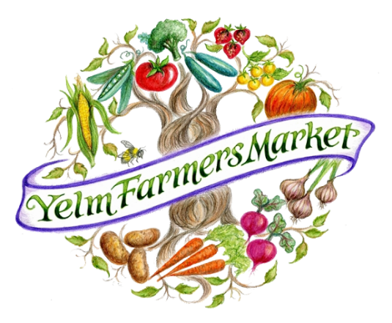
Yelm Farmers Market
Business Booth Application
2018 Market Season – Available Saturdays
May 26nd – October 27th . 10 am – 3 pm
Yelm Community Center, 301 2nd Street SE

Each market day Yelm Farmers Market offers one local business the opportunity to reach out to our market customers. With more than 600 adults on average visiting each day (in height of season more than 850+), this is an excellent opportunity to interact with our community in a relaxed family-friendly environment. Approved businesses are invited to promote – but not sell – their products and services at the market. Sign up now for your booth, there are only 22 markets this season!

Participation Level | Market Day Fee
PoP (Power of Produce) Presenting Sponsor-$5,000 Prime marketing presence and benefits, plus up to 5 market booths | No Charge - 5 markets
Music Booth Presenting Sponsor- $3,000 SOLD Prime marketing presence and benefits, plus up to 3 market booths | No Charge - 3 markets
Market or PoP Cultivator-$1,000 Website, social media, enews, market banner id, brochures at info booth, plus up to 2 market booths | No Charge - 2 markets
Market or PoP Germinator-$500 Website, enews, market banner id, plus up to 2 market booths | No Charge - 2 markets
Market or PoP Sower-$200 Website, market banner id, reduced fee ($25) to operate educational/relevant promotion 1 market booth | $25 1 market
All other approved Business Booth approved businesses (you may come up to 3 times in the season, paying each day you appear) | $50 each market

See our Sponsorship Opportunities Package at http://bountyforfamilies.org/ for more details on the business marketing sponsorship with tremendous benefits (PoP Presenting Sponsor; Cultivator; Germinator and Sower).

To register your interest, fill in the form below and email to manager@yelmfarmersmarket.com or post to Yelm Farmers Market, PO Box 2583, Yelm WA 98597. Priority will be given to services or businesses that have products directly related to sustainability. ONLY LOCAL businesses, and only those that do not directly compete with current or potential vendors.
Business Booth Name of Business : ____________________________________________________
Contact: __________________________________ Phone: ________________________________
Email: ___________________________________________________________________________
Nature of business promoted : ________________________________________________________
Preferred Days: __Day 1: _____________Day 2: __________________Day 3: __________________
Upon receipt of your interest form, the market manager, will contact you regarding a review of your application.
On behalf of the Yelm Farmers Market, THANK YOU for joining us in our
commitment to the health and well-being of our community.

