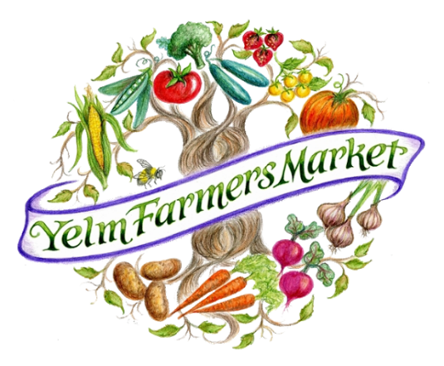
Yelm Farmers Market
Non-Profit Booth Application
2018 Market Season – Available Saturdays
May 26nd – October 27th . 10 am – 3 pm
Yelm Community Center, 301 2nd ST SE

Each week the Yelm Farmers Market offers a booth to one not-for-profit organization or municipality as an opportunity to outreach to our market customers. Our mission is to:
- Provide an opportunity of our customers to learn about local organizations
- Support non-profits in the community, and,
- Provide a venue for cities and municipal departments to educate the community about special projects and educational outreach efforts.

Priority will be given to non-profit organizations with a strong membership base and an educational engagement program or service that is related to sustainability, community asset building, and health. The booth is provided for $35. Full participation in the set up and breakdown of the booth is required of the volunteers and staff that come to represent the non-profit assigned. In a 10 X 10 area, a 6-foot table will be available for use. Participants will be required to bring their own chairs, booth displays and garbage disposal. No hawking, no sales of any items, nor giveaways of any edibles is allowed. No selling of any raffle tickets, nor tickets to any event. The non-profit may PROMOTE and EDUCATE and SIGN UP potential ticket buyers or future supporters of the organization by talking about their programs, handing out brochures, and signing up people for a mailing list. The solicitation for money and donations is prohibited, as the farmers and other vendors at the market are in direct competition for customers’ limited dollars to buy their products so that they can make a viable and sustainable living.

The Non-Profit Organization that is approved for representation at the market is required to:
- Promote in advance the appearance of that Non-Profit at the market, 1) tying in the following handles on the week that they are scheduled to appear, and 2) Posting their appearance at the market using their FB, Twitter, Instagram accounts on the day of. Facebook: Yelm Farmers Market; Instagram: YelmFarmersMarket; Twitter: YelmFarmersMarket
- Show up on time! Be there no later than 9:00 am to set up and be ready to promote at 9:45 am.

Sign up now for your booth, the market opens May 26th! Pick a preferred Saturday between May 26th and October 27th!

To register your interest, fill in the form below and email to manager@yelmfarmersmarket.com or post to Yelm Farmers Market, PO Box 2583, Yelm WA 98597. Priority will be given to non-profits that apply with interest early, and who have like-minded missions and community objectives.
Name of Non-Profit: ____________________________________________________
Contact: __________________________________ Phone: ________________________________
Email: ___________________________________________________________________________
Mission of NPO: __________________________________________________________________
Preferred Day 1: ____________________ Preferred Alternate Day 2: __________________
Upon receipt of your interest form, the market manager, will contact you regarding a review of your application.
On behalf of the Yelm Farmers Market, THANK YOU for joining us in our
commitment to the health and well-being of our community.

