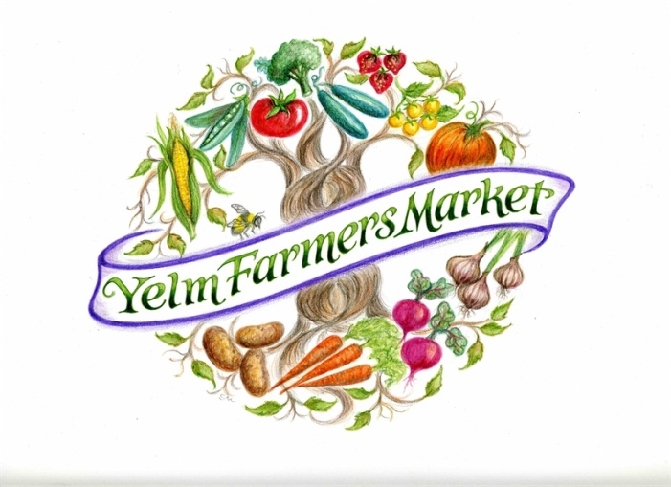**Yelm Farmers Market. May 26-Oct. 27, 2018.**

**Vendor Application and Contract**

**Priority Application Deadline: April 8th, 2018.**

(Applications are welcome throughout the season but priority shall be given to returning vendors, then new vendors, who submit their application before April 8th, 2018.)

Farm/Business Name: _______________________ Vendor Name: ________________________

Name to which reimbursement checks are to be written: _________________________

On-Site Contact: _____________________________

Mailing Address: _____________________________________________

City: __________________________________ Zip: _______________

Physical Address of Farm/Business: ________________________________

City: _______________ Zip: __________________

Home Phone: ______________________

Office Phone: _____________ Cell Phone: _______________________

Email: _______________ Web Site: _________________________

Facebook:

Other social media handles:

**A. FARM VENDORS** *(Includes value-added products using your own farm products)*

Other

|  |  |
| --- | --- |
| List all crops or items you intend to sell (or attach a separate list): | Check Availability (seasons): Spring – for May-June, Summer – for July-August, and Fall – Sept-Oct |
| Crop:  Crop:  Crop:  Crop:  Crop:  Crop:  Crop:  Crop:  Crop:  Crop: | Spring  Summer  Fall  Spring  Summer  Fall  Spring  Summer  Fall  Spring  Summer  Fall  Spring  Summer  Fall  Spring  Summer  Fall  Spring  Summer  Fall  Spring  Summer  Fall  Spring  Summer  Fall  Spring  Summer  Fall |

Vendor:

Do you produce all of these products yourself? Yes  No

Are your products certified organic? Yes  No

*If yes, please attach a copy of organic certification.*

Are your products grown in a method similar to certified organic growers, but without the certification? Yes  No, I do apply conventional growing methods, using fertilizers, pesticides or fungicides.

If Yes, Please describe your growing practices:

Do you plan to offer samples of your fresh fruits and vegetables? Yes  No

*If yes, please contact the market manager and the County Health Department for licenses, applications and fee schedule.*

**B. PROCESSOR VENDORS** *(Includes items made NOT using your own farm products)*

Types of Products:  Baked Goods  Preserved Goods

Other

For acceptance into the market, processors will need to provide copies of all necessary licensing as required by the Washington State Health Department prior to the commencement of the market season.

|  |
| --- |
| List all items you intend to sell (or attach a separate list): meats, seafood, ciders, wines, baked goods, jams, nuts, etc.) that have added value to their product through some sort of “hands-on” processing |

Processed (Value Added) items:

|  |
| --- |
| List ingredients grown in Washington State (if any): |

Ingredients that were from Washington:

Do you plan to offer samples of your fresh fruits and vegetables? Yes  No

*If yes, please contact the market manager and the County Health Department for licenses, applications and fee schedule.*

Vendor:

**C. RESELLERS**

Reseller must buy directly from farmers in Washington State. Crops must be pre-approved before delivery to market as preference is always given to primary producers and to farmers within the Yelm geographic area. See the full description in the Rules and Policies of the Yelm Farmers Market.

|  |  |  |
| --- | --- | --- |
| List all crops or items you intend to sell (or attach a separate list): | | Check Availability (seasons): Spring – for Mid-May-June, Summer – for July-August, and Fall – Sept-Oct |
| Crop:  Crop:  Crop:  Crop:  Crop: | Spring  Summer  Fall  Spring  Summer  Fall  Spring  Summer  Fall  Spring  Summer  Fall  Spring  Summer  Fall | |

**D. PREPARED FOOD VENDORS**

Prepared Food vendors should use ingredients produced in Washington State as much as possible. No new items may be added to your menu without permission from the Market Manager.

|  |
| --- |
| List all items you plan to sell (or attach a separate list/menu), add the approximate price next to the item, please. |

Prepared food items:

Do you require electricity? Yes  No

*If yes, please describe devices requiring electricity and the total amps needed for each:*

**E. ARTISAN VENDORS** *(pending available space and approval by Market Manager)*

*All items must be crafted/created by the seller. No resale items are allowed. New vendors must have all items screened by the Market Manager. Artisans/Crafters should incorporate materials grown or produced in Washington State as much as possible and create their products in Washington State only.*

Vendor:

(Artisans cont.) Describe all items you plan to sell (or attach a separate explanation).

List:

**F. ALL VENDORS**

List all other markets where you will be selling in 2018:

Please list the names of family members or employees who may sell for you:

Please include a copy of the following with your application:

**All vendors (some exemptions for small farmers):**

State Master Business License # ____________________

Please also include the following – where applicable (call or email with questions):

**Artisans:**

Submit photos, a website link to view products, or samples of work for the YFM Manager

**Processed Food:**

WSDA Food Processors License

WSDA Cottage Food Operation permit (if applicable)

WA Dept of Health Food Worker Card

Certificate of Product Liability & General Liability Insurance (when applicable)

**Prepared Food:**

Thurston Co. Public Health District Temporary Food Establishment Permit, or, Mobile Food Truck permit

WA Dept of Health Food Worker Card

Certificate of Product Liability & General Liability Insurance (when applicable)

**Farmers:**

WA State Nursery License (if you plan to sell plants, bulbs or seeds)

WA Dept of Licensing Egg Handlers Permit & WSDA Labels (if you plan to sell eggs)

WSDA Milk Producers License, WSDA Milk Processing Plant License (for dairy products)

Certification of Organically Grown Produce (if applicable)

WA Dept of Fish & Wildlife Wholesale Fish Dealer License or Direct Retail Endorsement License

WA Dept of Health Food Worker Card (for sampling)

Certificate of Product Liability & General Liability Insurance (when applicable)

Vendor:

**G. 2018 MARKET DATES - Market at Yelm Community Center, 301 2nd Street**

I will be attending all market days OR

I request to be scheduled on the market dates checked below*

May 26

June 2 9 16 23 30

July 7 14 21 28

August 4 11 18 25

September 1 8 15 22 29

October 6 13 20 27

\**Dates must be approved by Market Manager. You will be contacted to confirm your requested dates. Identifying dates in advance (above) or notifying the Market Manager at least 48 hours in advance excuses you from the No-Show List. Additionally, booths not occupied by 10:00 am on any given market day will not be held and that day you will be listed as a No-Show. After four (4) No-Show occurrences the Market Manager will decline space to the vendor for the remainder of the season.*

**H. APPLICATION & STALL FEES**

The Yelm Farmers Market 2018 fees are $15 per day or $300 for the entire season of 22 weeks (a 9.09% discount) per each 10’ x 10’ stall **AND** a percentage of gross sales as follows: 5% for farmers, 7% for all other vendors. Please refer to the 2018 YFM Guidelines and Policies for more details.

The full season fee for stalls is payable by **May 19, 2018.**

An application fee of $20 must accompany this application. Vendors new to YFM must also include at least one (1) day’s stall fee. These are fully refundable if not accepted into the market. An application will not be processed until these are included with the form.

Please enter the amounts that you are submitting:

|  |  |
| --- | --- |
| Application Fee: $20 | Enter $. |
| Stall Fee: $15/day x number of days circled OR $300 for entire season |  |
| TOTAL AMOUNT SUBMITTED WITH APPLICATION | Sum |

1. **Email** in the entire YFM_Vendor_Contract_Application_Form_2018_blank as a Word attachment or google doc to [manager@yelmfarmersmarket.com](mailto:manager@yelmfarmersmarket.com).
2. Then**, print out the last page and sign** to submit as a hard copy printed paper with your payment. You may mail or drop off the last page at the Yelm Food Coop at 308 E Yelm Avenue during business hours Mon-Sun. Ask a manager where the mail drop box is in the office for the Yelm Farmers Market.

Multiple stall rentals may be available. Please contact the market manager for further information, [manager@yelmfarmersmarket.com](mailto:manager@yelmfarmersmarket.com).

Vendor: ***PRINT OUT THIS LAST PAGE! Sign it please***

**I. VENDOR AGREEMENTS after signing– scan/email or mail**

|  |  |
| --- | --- |
| We may receive requests from customers or the press for information about our vendors. May we give them your contact information? | Yes No |
| Do you agree to allow a farm/site visit by a Yelm Farmers Market Board Member or other designated person as a quality control and community building measure in place for the benefit of all vendors? *(Yes is required)* | Yes |
| It is required that the owner of the business be present at their booth on their first day at the YFM. Do you agree to be present at your booth on your first day of attendance at the market? *(Yes is required)* | Yes |
| May we promote your business on our website? | Yes No |
| Do you agree to post your business name and location on prominent signage in your booth? | Yes No |
| Do you agree to support the educational mission of the Bounty for Families by actively creating an atmosphere of learning at your booth? | Yes No |
| Do you agree to adhere to the 2018 Yelm Farmers Market Guidelines and Policies? | Yes |

Questions: Contact Market Manager at [manager@yelmfarmersmarket.com](mailto:manager@yelmfarmersmarket.com).

**Please Read and Sign Below**

I request permission to sell at the 2018 Yelm Farmers Market under the umbrella organization, Bounty for Families (formerly Yelm Cooperative). I have read and understand the YFM 2018 Vendor Guidelines and Market Policies and agree to the terms and conditions outlined in that information. I agree to cooperate with market management. I agree that I will accurately report my gross sales each week and that I will pay applicable stall fees and commissions weekly. I understand that if I do not pay what I owe each week I will be assessed a late charge of $25.00 payable before setting up for the following week’s market. I agree to follow all guidelines and to obtain all permits and/or licenses as required for my products according to the USDA/WSDA/ WSDOL and to provide proof of such permits or licenses to market management prior to the first market day. I agree to prominently display these permits and/or licenses at my market booth. I shall indemnify, keep, and save harmless the Yelm Cooperative and the City of Yelm from any and all claims and demands, whether for injuries to persons, or loss of life, or damage to property, on or off the premises, arising from the use or occupancy of the premises by the Vendor and shall defend at the Vendor’s own expense any action brought against the Market or the City of Yelm by Vendor’s acts or omissions.

Vendor Name:

Vendor Signature: _______________________________________ Date: _______________________

Business Name:

**RETAIN A COPY FOR YOUR RECORDS**

|  |  |
| --- | --- |
| Please remit to: Yelm Farmers Market  PO Box 2947  Yelm, WA 98597 | **For Market Use Only**  ___________ Date Received _____Business License  ___________ Payment Received ______Dept of Health |

***Use Paypal button on Yelm Farmers Market “Donate” button and indicate: YFM fees, or mail in this page with a check.

**Yelm Farmers Market. Yelm Community Center, 301 2nd Street. May 26-Oct. 27, 2018**